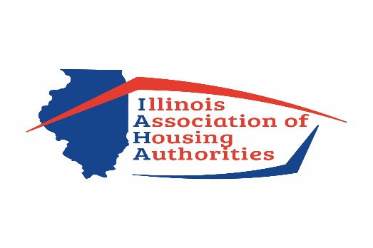

May 20, 2020
Mr. Michael Madigan, Speaker of the House
Mr. Jim Durkin, Republican Leader of the House
Mr. Don Harmon, Pres. of the Senate
Mr. William Brady, Republican Leader of Senate

Subject; HB 5574
Dear Legislative Leaders:
The Illinois Association of Housing Authorities which is comprised of 105 Illinois Housing Authorities, is strongly opposed to HB 5574 that is being currently considered within the scope of COVID -19 legislature.
Several of the points not only will hurt Housing Authorities, but also private landlords throughout the State of Illinois. Regarding Housing Authorities:
- It is highly probable that rents will be uncollectible for the moratorium period of this bill let alone after the moratorium. The result of this would mean approximately a 40% loss of income which will severely hinder Housing Authorities operations. It would mean more loss of income for private landlords.
- The provision of not being able to file and ultimately collect past due rent during the moratorium period.
- The highly confusing and lengthy notification process once the moratorium is lifted, giving a person that is past due at a minimum another 120 days whereas they do not have to pay rent.
- The burden of proof that Housing Authorities will have to obtain in order to know if they non-payment of rent is truly COVID-19 related and the obstacles that are already in place to obtain this information.
- Moneys not being readily available for the relief of landlords and tenants as well as not defined of how to get this money.
These are just some of the points. Please do not let this bill pass as it is written now without major revisions and I suggest, input from private landlords and Housing Authorities.
Sincerely,
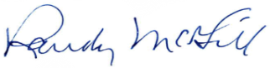
Randy McGill
President IAHA

